Protechsoft day2 grooming notes

1. What is CSS?
CSS stands for Cascading Style Sheets.
It is used to design and style web pages.
HTML provides the structure, while CSS provides the appearance.

Q1. What is CSS?
Ans: CSS stands for Cascading Style Sheets and is used to style web pages.
Q2. Why do we use CSS?
Ans: To improve the appearance and design of webpages.

2. Ways to Apply CSS
There are 3 ways to write CSS:

1. Inline CSS
<h1 style="color: red;text-align: center; "> welcome to css grooming</h1>

2. Internal CSS
<style>

h3{
color: green;
}
</style>

3. External CSS
<link rel="stylesheet" href="style.css">

h4{
color:blue;
}

Advantages of External CSS
- Code reusability
- Easy maintenance
- Better readability
- One CSS file can style multiple pages
Q1. How many ways can we apply CSS?
Ans: 3 (Inline, Internal, External)
Q2. Which CSS method is most preferred?
Ans: External CSS.

3. Difference Between ID and Class Selector
ID Selector | Class Selector
Represented by # | Represented by .
Must be unique | Can be used multiple times
One element should have one unique ID | Multiple elements can share the same class
Q1. Which symbol is used for ID selector?
Ans: #
Q2. Which symbol is used for Class selector?
Ans: .

4. Hover Pseudo Class
Hover is applied when the mouse pointer is placed over an element.

Example

<button id="login"> login </button>

#login{
background-color: green;
}

#login:hover{
background-color: red;
color:cyan;
}

5. Focus Pseudo Class
Focus is applied when an input field becomes active.

Example
<input type="text" id="inp1">

#inp1{
outline: none;
}

#inp1:focus{

background-color: brown;
border: 2px solid blue;
}

6. Box Model
Every HTML element is considered a rectangular box.
The Box Model consists of:
- Content
- Padding
- Border
- Margin
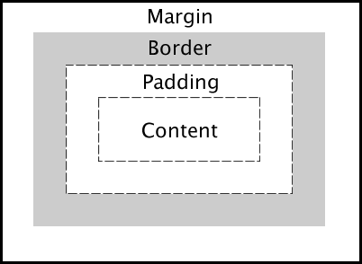

Example
<div id="card">

<h1 >i am card1</h1>
</div>

#card {
width: 350px;
height: 250px;
border: 2px solid black;
padding: 10px;
margin: 50px;
}

7. Div Tag
<div> stands for Division.
It is a block-level container used to group elements together.

Example
<div>
<h1>Hello</h1>
<p>Welcome</p>
</div>

8. Create one Profile Card
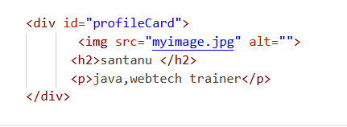
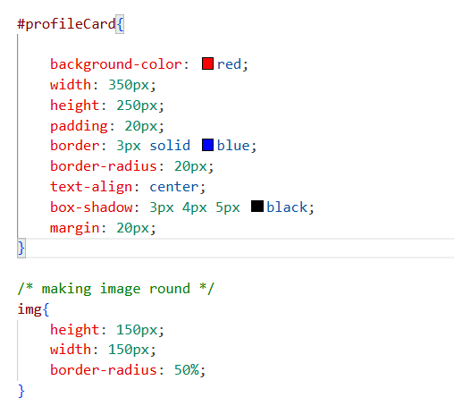

9. Transition
Transition is used to create smooth changes between property values.

Transition Properties
Property | Purpose
transition-property | Property to animate
transition-duration | Time taken
transition-timing-function | Speed curve
transition-delay | Delay before animation

Common Timing Functions
- ease
- ease-in
- ease-out
- ease-in-out
- linear

Example
<div id="circle">

</div>

#circle{
height: 200px;
width: 200px;
background-color: purple;
transition: all 1s ease-in 1s;
}

#circle:hover{

background-color: red;
}

10. Text Properties
Used to style text.

Example
<h1 id="grooming"> welcome to webtech grooming</h1>

#grooming{
text-align: center ;
text-transform: capitalize;
letter-spacing: 5px;
text-shadow: -10px -4px 6px blue;
}

Important Text Properties
Property | Purpose
text-align | Align text
text-transform | Change case
letter-spacing | Space between letters
text-shadow | Shadow effect

Values of text-transform
- uppercase
- lowercase
- capitalize

11. Font Properties
Used to change the appearance of fonts.

Example
<p id="para1">this is day2 topic</p>

#para1{
font-size: 30px;
font-style: italic;
font-weight: bold;
font-family: Verdana, Geneva, Tahoma, sans-serif;
}

Important Font Properties
Property | Purpose
font-size | Size of text
font-style | Normal/Italic
font-weight | Thickness of text
font-family | Font type

